**Fanka Shundovska**

**IntelliJ – JAVA Homework 4**

1. Display the name of the month by rewriting this code in switch statement.

int month = 9;

String monthString = null;

if (month == 1) {

monthString = ("January");

} else if (month == 2) {

monthString = ("February");

} else if (month == 3) {

monthString =("March");

} else if (month == 4) {

monthString =("April");

} else if (month == 5) {

monthString =("May");

} else if (month == 6) {

monthString =("June");

} else if (month == 7) {

monthString = ("July");

} else if (month == 8) {

monthString = ("August");

} else if (month == 9) {

monthString =("September");

} else if (month == 10) {

monthString = ("October");

} else if (month == 11) {

monthString =("November");

} else if (month == 12) {

monthString =("December") ;}

System.out.println(monthString);

/*String month = String.valueOf(7);  
switch (Integer.parseInt(month)) {  
 case 1:  
 System.out.println("January");  
 break;  
 case 2:  
 System.out.println("February");  
 break;  
 case 3:  
 System.out.println("March");  
 break;  
 case 4:  
 System.out.println("April");  
 break;  
 case 5:  
 System.out.println("May");  
 break;  
 case 6:  
 System.out.println("June");  
 break;  
 case 7:  
 System.out.println("July");  
 break;  
 case 8:  
 System.out.println("August");  
 break;  
 case 9:  
 System.out.println("September");  
 break;  
 case 10:  
 System.out.println("October");  
 break;  
 case 11:  
 System.out.println("November");  
 break;  
 case 12:  
 System.out.println("December");  
 break;  
 default:  
 System.out.println("Invalid input");  
 break;  
}*/

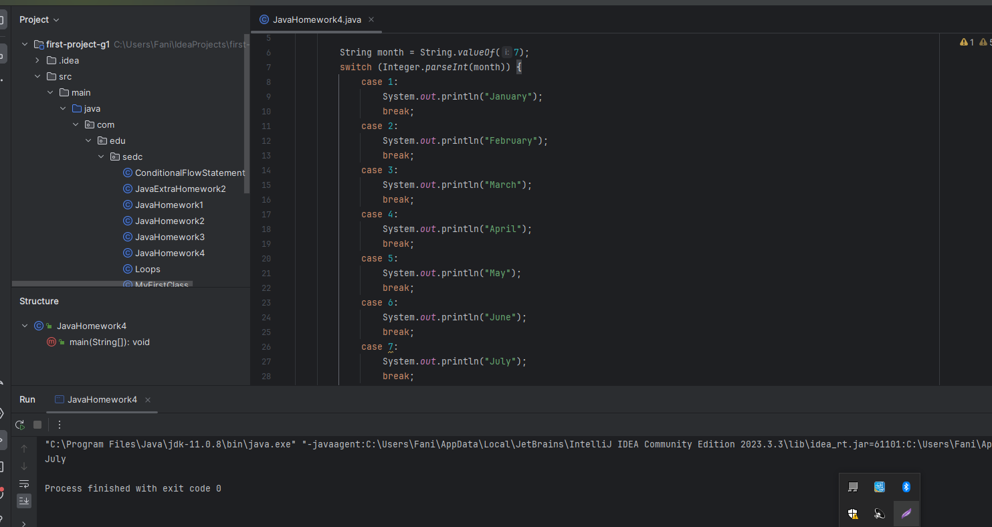

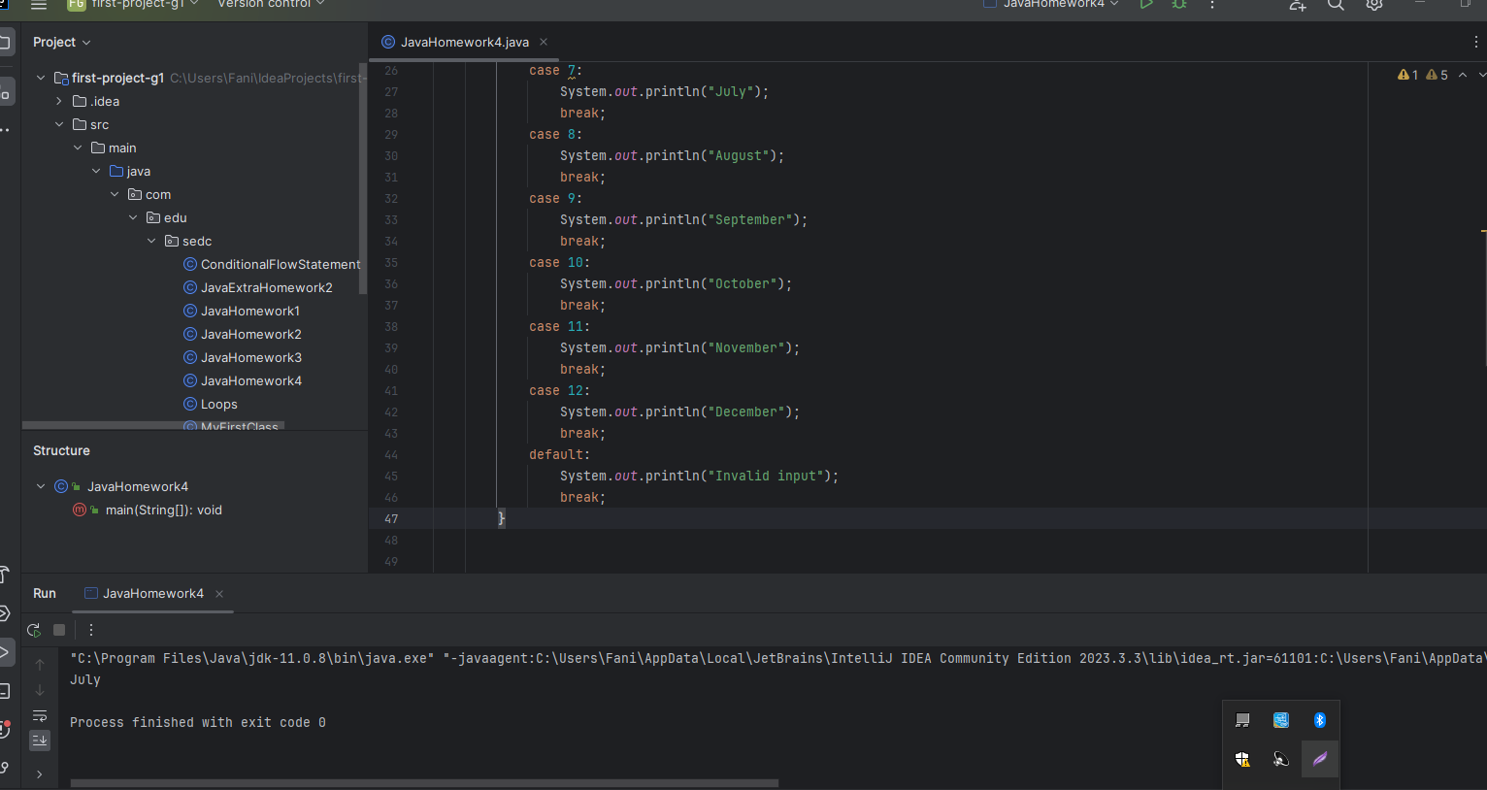

1. The code below is supposed to print the integers from 10 to 1 backwards. What is wrong with it? Correct the code so it does the right thing.

count = 10;

while (count >= 0)

{ System.out.println(count);

count = count + 1; }

int count = 10;

while (count > 0) {

System.out.println(count);

count = count - 1;

}

Or we can get results with:

/*for(int a=10; a>=0; a--){  
 System.out.println(a);  
}*/

1. Write a program to print numbers from 1 to 15.

/*for (int i = 1; i <= 15; i++) {  
 System.out.println(i);  
}*/

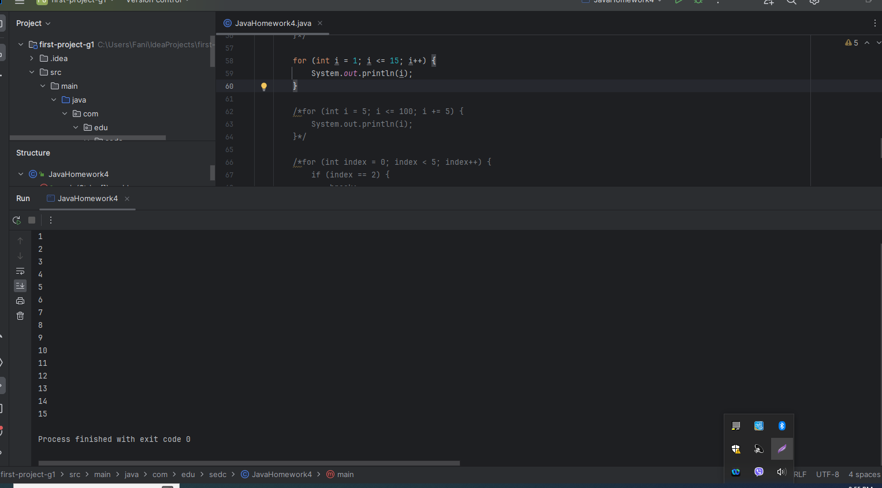

1. Print the integers from 5 to 100 by 5s (e.g. 5, 10, 15, and so on).

/*for (int i = 5; i <= 100; i += 5) {  
 System.out.println(i);  
}*/

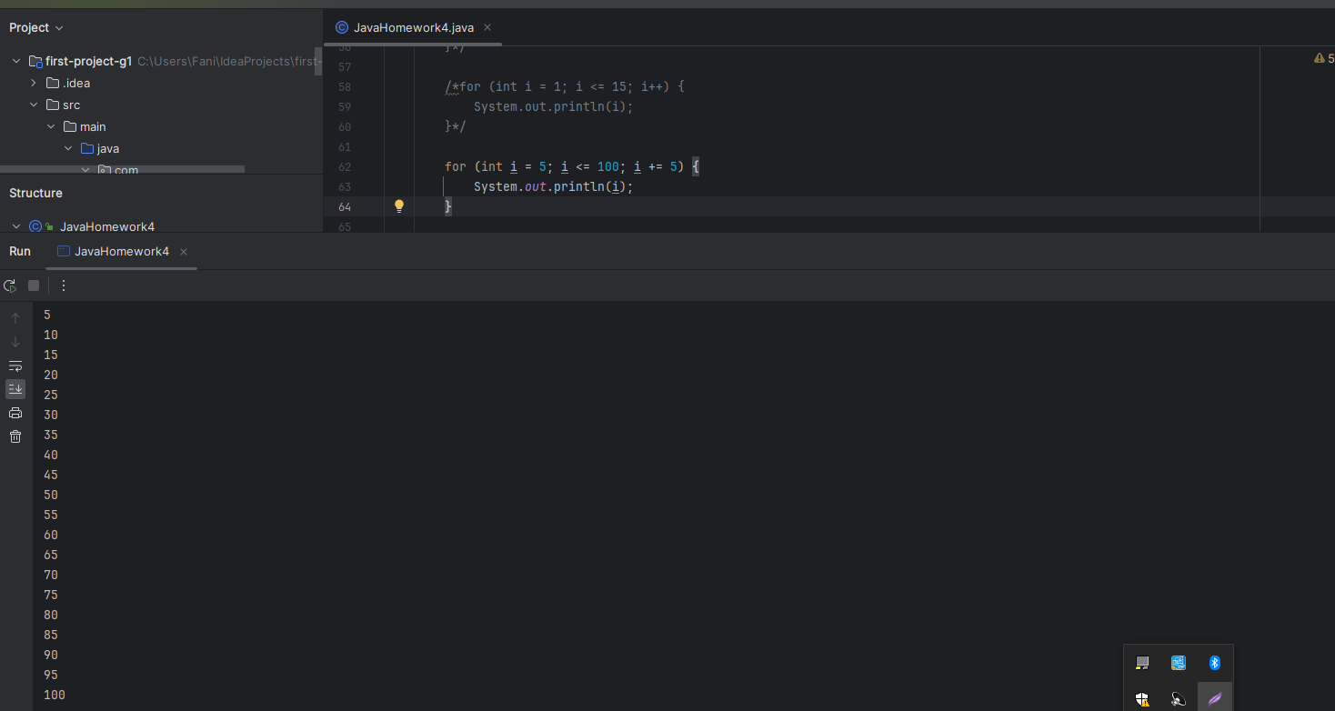

1. Write a code to break the loop:

for (int index = 0; index < 5; index++)

when index is 2.

/*for (int index = 0; index < 5; index++) {  
 if (index == 2) {  
 break;  
 }  
 System.out.println(index);  
}*/

